|  |  |  |  |  |
| --- | --- | --- | --- | --- |
| **Description of Test** | **Test data to be used** | **Expected outcome** | **Actual outcome** | **Comments and intended actions** |
| Navigation bar: Black box testing, Functional testing (Integration testing) | No input is needed now, check to see if the navbar has passed all the tests. Black box testing lets us examine the functionality from the user’s end. Testing integration ensures us that the nav bar seamlessly interacts with the links. For example, clicking on the energy page should take us to the energy page with minimum page load time. | The navigation bar has 5 sections and then the user’s profile. On the left, it has the company’s logo and on the right it has home, about us, energy, carbon calc and schedule. When hovering the writen darkens from a light black to a harsh black. When clicking on the link we should expect it to take us to that page. | * Nav bar works (all links to us to the correct page) * 1-3 sec load time | None |
| Homepage: White box testing, Black box testing: Functional and Integration testing, Unit testing | No data is needed as we are checking to see if the buttons work by doing black box testing. Also, ensuring the buttons co-operate with the rest of the website by doing integration testing. Using white box testing, we check if the code is logically correct (Also checking for syntac errors). | The homepage should be shown correctly, confirm all buttons work and pass WCAG. When the user clicks on ‘Log in’ or ‘Sign in’ it takes them to that page, If the user wants to learn more about ‘Green energy’ it should lead them to the energy page. Carbon calc naviagtes them to the carbon page. | * The log in and sign up now buttons work accordingly however the green energy and carbon one does not as I have no created a href link to the page * Page is properly integrated | Add a href link to both green energy and carbon calc buttons to take users to the desired page. |
| Log in / Sign up page:  Black box testing (Functional and integration)  White box testing (Unit testing) | Secure the user’s input. Testing with valid email or password formats.  If a user is logging in, check the corect credentials, verify the correct input and give an appropriate error message. Database integration, confirming that the user’s data is stored securely. Ensuring that the user is correctly directed to te next page once successfully logging or signing in. | Successful account should be created. The user should be logged in or signed up. A new record should be in the database with the details the user has provided (full name, email etc). |  | Add cookie policy to prompt the user to agree to the terms and conditions before continuing and for legal requirements.  Allow the user the option to sign in with ‘Google’ or ‘Facebook’.  Fix the interface of the page where the user will be directed once logging in/ signing up. |
| Log out | No data need | The log out button should be working. | Redirects user to homepage |  |
| Regression testing | Invalid user login attempt | An error message should be displayed |  | Works as intended, for future reference maybe instead of ‘Inavlid email or password’ do ‘Invalid email or password. Please try again’. |
| Regression testing | A field has not been filled in | Valid error message should be displayed | Works as expected. |  |
| About us page:  Black box testing (Functional testing and Non-functional testing)  White box testing (Unit testing) | This page does not require user input but more about content and presentation. Image verificaion, confirm all the images are there. Validate the href links, for example the carbon footprint button should direct the user to carbon.html. | Displays the three options Rolsa tech provides and a buttpn to ‘Learn more’ which directs them to reviews.html where they can find quotes on the service and some reviews.  Talks briefly about carbon footprint allowing the user to click on the button to explore more and calculate their own. |  | Add a href link to ‘Schedule now’ to direct the user to schedule.html. |
| Energy page:  Black box testing (Functional and integration)  White box testing (Unit testing) | This page requires user input if the user wishes to track their energy usage and also gives the user the oppurtunity to explore what rolsa tech has to offer. | Information should be shown correctly, ensuring that it is readable. To calculate the energy usage using an API. To redirect the user to book a call to action if stuck or unsure. | No calaculation was done correctly so I will fix this and use an API to do so. |  |
| Booking/ Scheduling page:  Black box testing (Functional and integration)  White box testing (Unit testing) | This page requires users to book an installation or schedule a consultation. Ensuring that the booking confirmations are displayed. Testing the selectio of different resources to ensure flexability. | To book an appointment successfully. Buttons should be displayed correctly. | The <img src is currently not working so research will be done although I believe it is due to the cache as previously it had worked. | Fix the img src tag  Make the option to log in more visable to the users |
| Carbon footprint page:  Black box testing (Functional and integration)  White box testing (Unit testing)  Usability testing | This page requires the users input to calculate their carbon footprint whilst also allowing them to learn more about it. | To calculate the carbon footprint successfully. | The function ‘calculateCarbonFootprint’ calculates the users estimated carbon footprint. | To ensure the user either logs in or sign up first. |
|  |  |  |  |  |

|  |  |  |  |  |
| --- | --- | --- | --- | --- |
| **Content** | **Type** | **Source** | **Purpose** | **Date** |
| Background Picture/ Home | Image | <https://www.istockphoto.com/photo/solar-energy-panels-and-wind-turbines-gm493188080-76767435> | To make the website more appealing to the customer and give them an idea of what the website will hold. | First obtained during the design phase  11/03/2025 |
| Green energy | Image | <https://www.magazine.unimore.it/site/home/notizie/articolo820066054.html> | Letting the user know what the section is about without having to read the information. | First obtained during the design phase  11/03/2025 |
| Solar Panel | Image | <https://solarplanet.uk/comprehensive-guide-to-solar-panel-sizes-and-their-significance/> | Gives the user an idea of what the solar panel would look like. |  |
| EV charging  Stations | Image | <https://blog.evbox.com/uk-en/how-to-use-fast-charging-stations> | It offers the user a visual representation of how their car would look like with the product. |  |
| Smart home energy | Image | <https://theconversation.com/uk/topics/online-safety-bill-100144> | It helps the user envision what their home could be. |  |
| Carbon Footprint | Image | <https://energise.energy/world-ev-day/> | Visually appealing. |  |
| Rewards | Image | <https://www.shutterstock.com/search/laurel-cartoon?image_type=vector&page=17> | Visually appealing. |  |
| Manage | Image | <https://www.shutterstock.com/search/laurel-cartoon?image_type=vector&page=17> | Visually appealing. |  |
| Schedule consultation | Image | <https://www.vecteezy.com/free-videos/2d-animation-doctor?page=5> | Visually appealing. |  |
| Schedule installation | Image | <https://www.vecteezy.com/free-videos/2d-animation-doctor?page=5> | Visually appealing. |  |

**Version 1**

Initial homepage

Functional requirement

The system shall display the homepage with navbar, main section, and footer.

There are no inputs of data needed on this page only if the user wishes to log in or sign up. The user should be taken to the necessary page when clicking on the links to other pages. For example, when clicking on the "Schedule" button, the booking page should be displayed immediately.

Navigation bar consists of:

* Home
* About
* Energy
* Carbon FP
* Schedule
* Account

Index.html

Currently, this is my homepage where the user can access the nav bar efficiently. It also allows the user to log in and sign up without any confusion or hardship. It is a clear and easy design where customers can access what they want.

|  |  |
| --- | --- |
| **The design** | **The prototype** |
|  |  |

Rolsa technologies was built with a fundamental focus on user experience. It boasts a well-designed interface which includes key UI/UX features that make it useful and easy to use. The aim was to create a desirable website that functions whilst looking aestherically pleasing. I believe this website strongly repersents the company Rolsa tech due to consistent visual elements which showcase a general idea of what the company is about.

When hovering buttons the button turns #003366

In my next version, I will enhance user privacy in line with GDPR requirements. This includes adding a robust and user-friendly mechanism which will allow users to accept or decline non-essential cookies.

Sign up / Log in

|  |  |
| --- | --- |
| The design | The prototype |
|  |  |

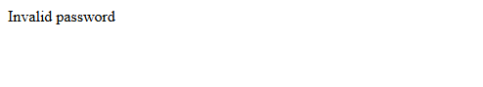

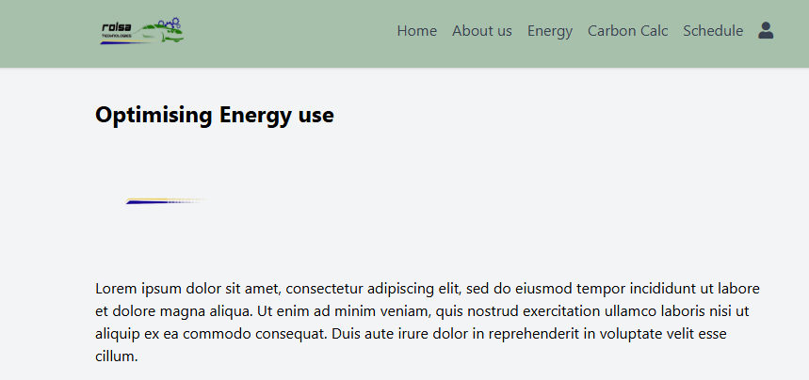

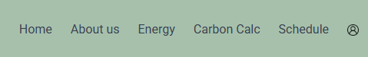

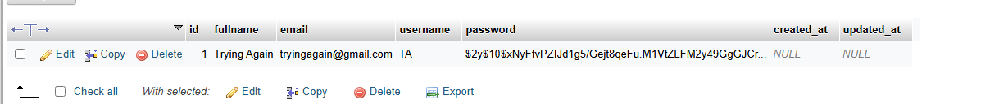

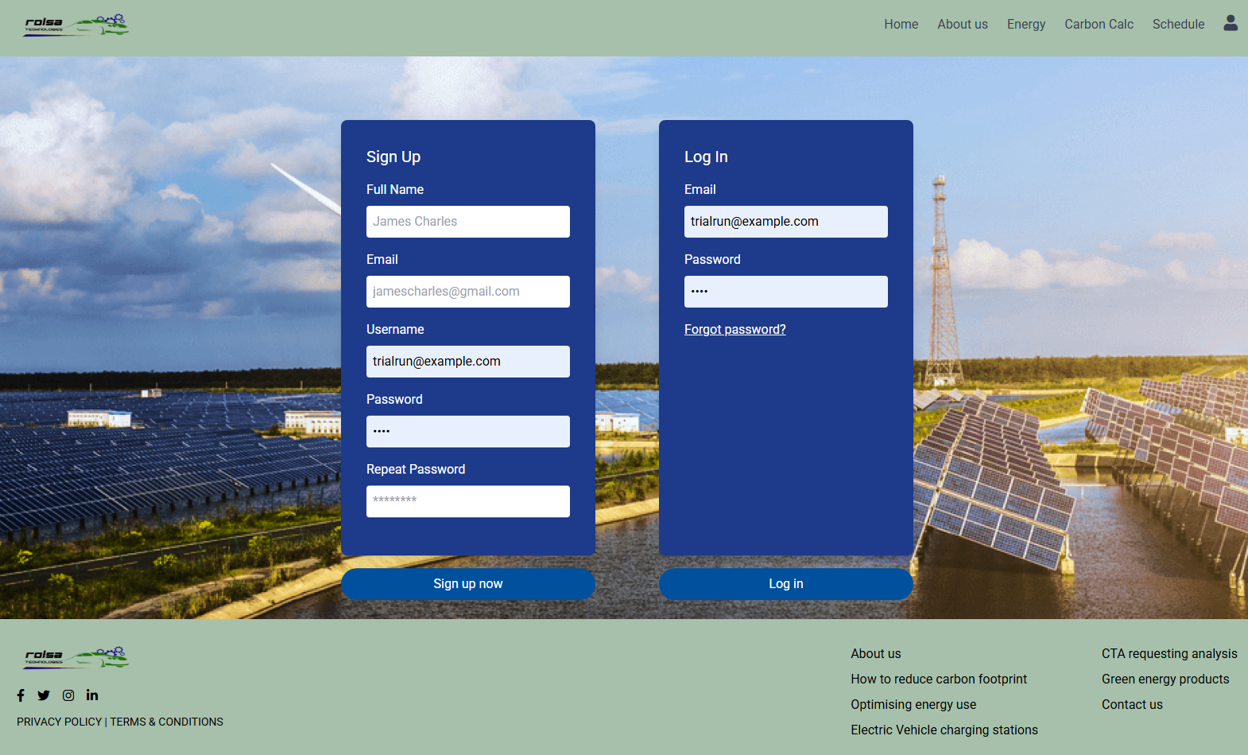

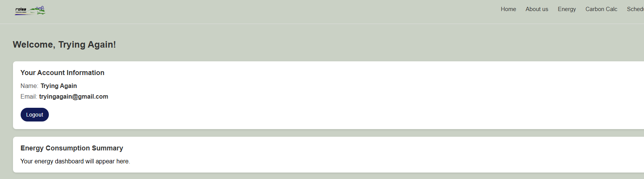

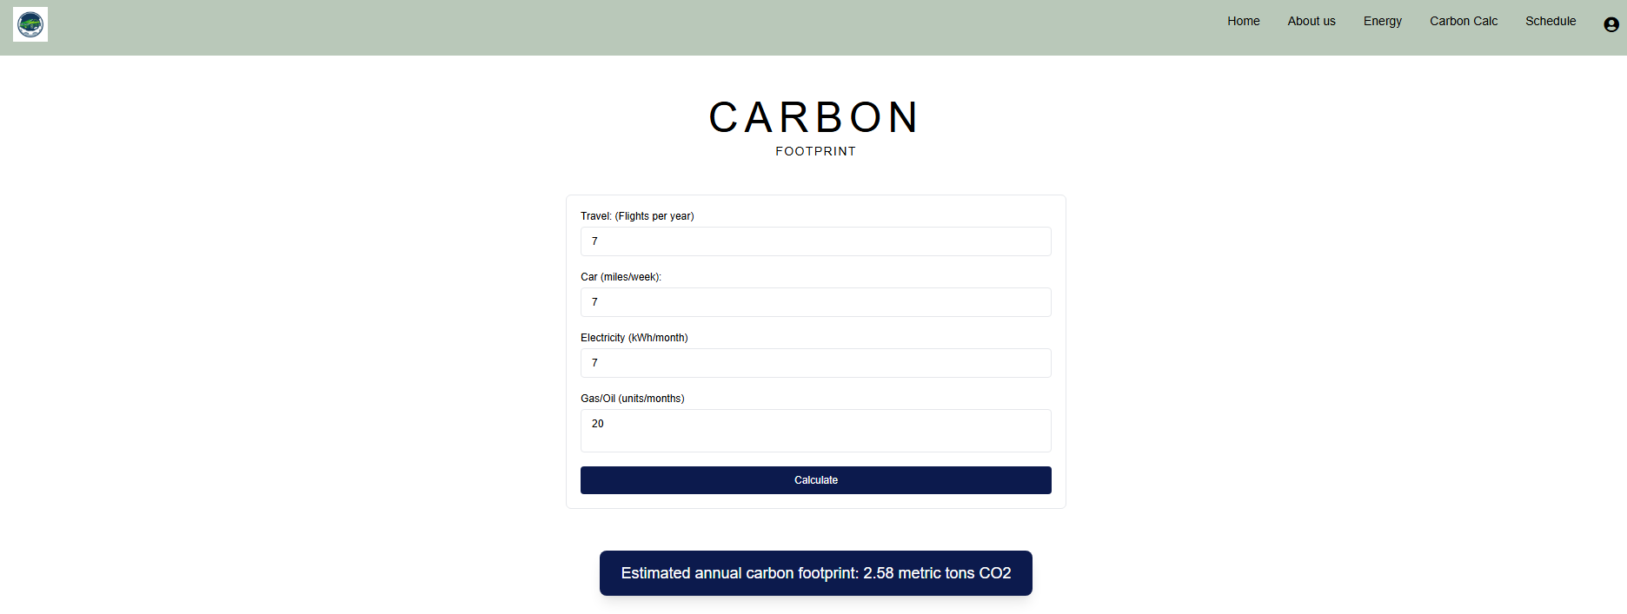

* Fix the nav and looks but works well with the use of JS and API

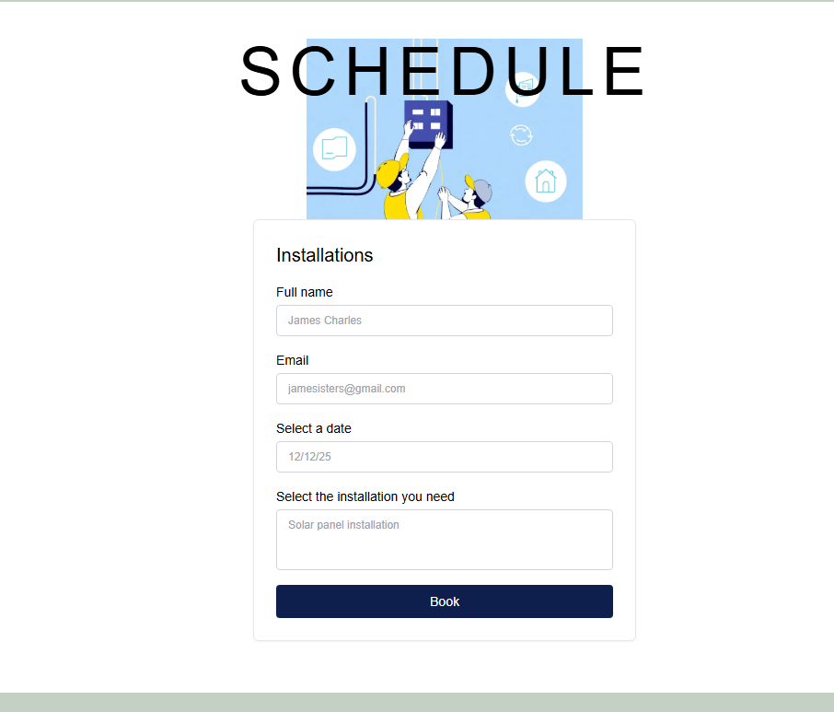

* Need to link to the databse and fix the nav and footer